CE 397 Statistics in Water Resources
Exercise 5 – Key
Analyzing Trends
Assignment due: 3/10/09
- Turn in a graph of the data with the trend lines and equations for Analyses 1-5, plus a table that summarizes the five trend equations and their R² values. Discuss the results. Which relationships do you think are statistically significant? What is the population growth rate per year?

Below we see the plots showing the increase of population and water use over time. We also see the pattern of water use as a function of population growth. As implied in the exercise, total water use doesn’t consistently grow over time, but municipal water use does. This is quite interesting. The trend in total water consumption per year indicates that over the past 35 years, Texans have changed the way they use water but have not been using that much more water. Municipal water use is changing, however, so other types of water consumption must be dropping. This would make sense if agricultural land is converted to residential use and the water consumption associated with each of those uses also shifts. Graphs of population growth over time and the growth of municipal water use with population make this explanation seem reasonable.

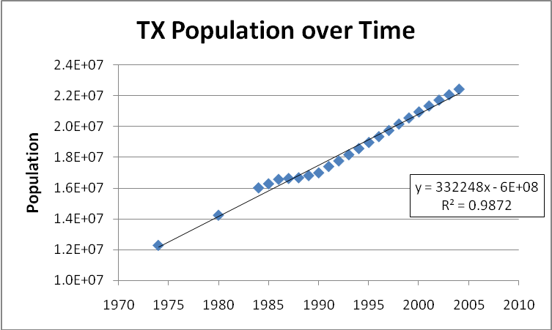

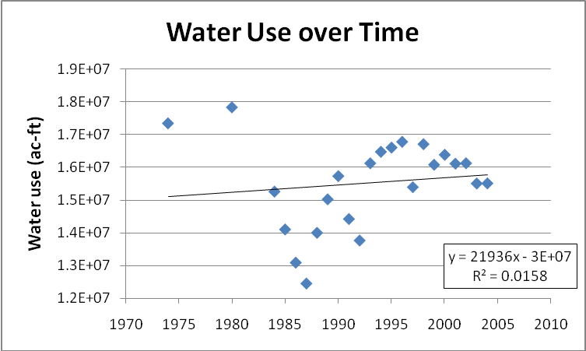

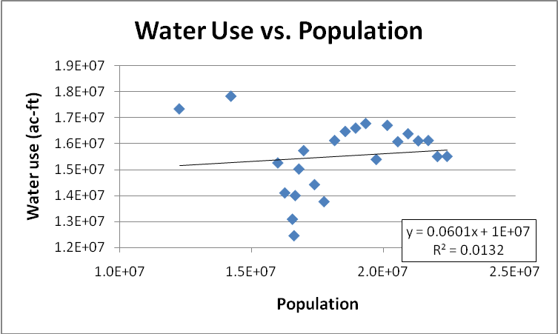

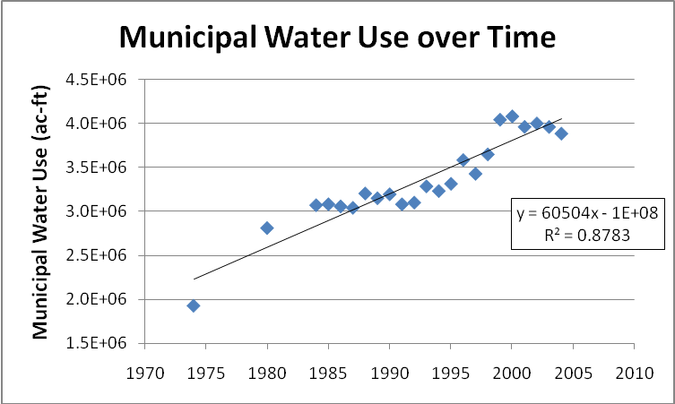

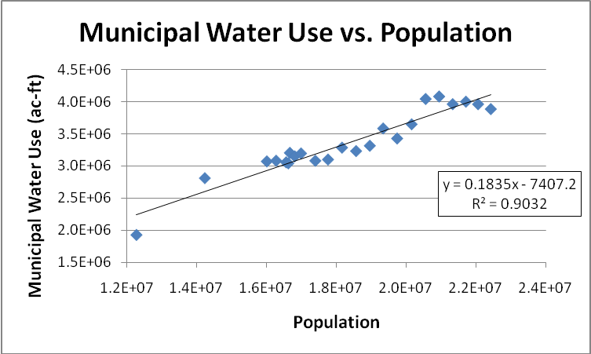

The linear regression equations associated with each of these analyses are shown in the following table. Based on the r² values, the equation that does the best job predicting variations in the dependent variable as a function of the independent variable is the equation for population change over time. This results in an increase of 332,248 people per year in the State of Texas. Wow; that’s a lot of people. The equations describing the growth in municipal water use over time and as a function of population growth are also fairly strong. Total water use trends over time and with population show basically no statistical strength. We should, therefore, not try to model future total water use with these equations.

Analysis | Equation | r²
Population over Time | P = 332248*t – 6*10⁸ | 0.9872
Water Use over Time | WU = 21936*t - 3*10⁷ | 0.0158
Water Use vs. Population | WU = 0.0601*P + 1*10⁷ | 0.0132
Municipal Water Use over Time | MWU = 60504*t - 1*10⁸ | 0.8783
Municipal Water Use vs. Population | MWU = 0.1835*P - 7407 | 0.9032

- Turn in the table of interpretive statistics from the simple regression of municipal water use vs population for the regressions with and without an intercept. Write both equations in the format illustrated above. Which equation has the greater statistical significance? What is the average municipal water demand in gallons per capita day in Texas? Is it changing through time? Note: 1 acre-ft = 325,851 US gallons.

Below are shown the outputs of the regression analysis on municipal water use vs. population both with and without an intercept. The equations below the outputs summarize the relationships and give an indication of the strength of each in describing the relationship between the variables. To see which equation does a better job of describing the relationship we look at the values of the r², standard error, and F value. The larger r², larger F value, and a smaller standard error point to the second equation (the one without an intercept) as being the most significant. It is preferable, therefore, to use this equation to predict municipal water use as a function of population.

Analysis with an intercept:
SUMMARY OUTPUT
Regression Statistics
Multiple R | 0.950
R Square | 0.9037
Adjusted R Square | 0.899
Standard Error | 159033.1
Observations | 23
ANOVA
 | df | SS | MS | F | Significance F
Regression | 1 | 4.95309E+12 | 4.95309E+12 | 195.8398831 | 4.07023E-12
Residual | 21 | 5.31122E+11 | 25291521454
Total | 22 | 5.48421E+12
 | Coefficients | Standard Error | t Stat | P-value | Lower 95% | Upper 95% |  | Upper 95.0%
Intercept | -7407.23 | 242581.0433 | -0.030535072 | 0.97592867 | -511882.1239 | 497067.6648 |  | 497067.6648
Texas Population | 0.1835 | 0.013111428 | 13.99428037 | 4.07023E-12 | 0.156218287 | 0.2107517 |  | 0.2107517

Analysis without an intercept:
SUMMARY OUTPUT
Regression Statistics
Multiple R | 0.999
R Square | 0.998
Adjusted R Square | 0.953
Standard Error | 155380.1
Observations | 23
ANOVA
 | df | SS | MS | F | Significance F
Regression | 1 | 2.63914E+14 | 2.63914E+14 | 10931.31403 | 5.06446E-30
Residual | 22 | 5.31146E+11 | 24142978732
Total | 23 | 2.64446E+14
 | Coefficients | Standard Error | t Stat | P-value | Lower 95% | Upper 95%
Intercept | 0 | #N/A | #N/A | #N/A | #N/A | #N/A
Texas Population | 0.183 | 0.001751155 | 104.5529246 | 3.6128E-31 | 0.17945672 | 0.186720067

With an intercept:
Water Use = -7407.23 + 0.1835 * Population R² = 0.904 S_{e} = 159033 F = 195.84
(-0.03054) (13.994)

Without an intercept:
Water Use = 0.183 * Population R² = 0.999 S_{e} = 155380 F = 10931.3
(104.55)

The municipal water use per capita is shown as the slope of the linear equations. So, using the equation without the intercept, we estimate a water use of 0.183 ac-ft municipal water per person during this timeframe. This converts to 59,631 gallons/capita-yr or 163 gallons/capita-day. As analyzed, the constant slope of the trend line (see figure on page 3) indicates that the water use per capita per day is not increasing. Another way to look at the data, however, may indicate that a change in water use per capita-day has actually occurred. The following plot shows the data split into 3 general categories of population. This analysis makes it look like our consumption rates may be reducing as the population grows. Further analysis would be required, however, to determine if these trends are statistically different or just part of the variability in the data.

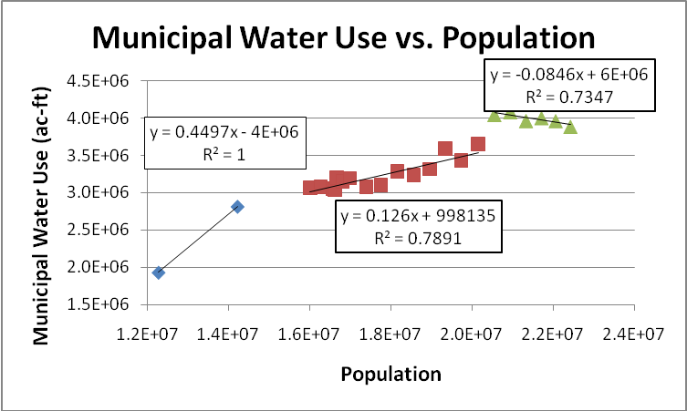

- Using the procedure outlined from Helsel and Hirsch, does the point for municipal water use in 1974 have high leverage? Is this point an outlier?

First let’s calculate the deviation in the x-direction

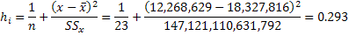

This value is greater than 0.261 (calculated as 3p/n) so it is considered to have high leverage. Now let’s check out the y-direction. If we look at the output of our residuals we see that the residual for this point is -314,808.6. We use the standard error of the equation and the h_{i} value to calculate the standard residual as

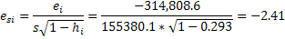

Since the absolute value of |-2.41|<3, the value is not an outlier in the y-direction according to this test.

- Present the output table of regression statistics and write the estimated model for a country’s fresh water withdrawals as a function of population, GDP, and average annual rainfall in the standard form with t-statistics, R², S_{e} and F ratio. Are there any coefficient estimates that are not statistically significant? If so, which ones? How can you tell? What is the average fresh water withdrawal per person (gpcd) derived from the equation? Compare this to the values derived directly from the data for each country. How is the average value of gpcd derived from the equation different from the average of the gpcd values derived directly from the data? What is the significance of the positive coefficient on GDP? [1 cubic meter = 264.17 US gallons].

Below is shown the output from the multiple linear regression analysis that was performed in Excel. Also shown is the equation summarizing the output of this analysis as a linear relationship. This relationship predicts a country’s freshwater withdrawals as a function of population, GDP (in $ billion), and the average annual rainfall in the largest city.
Fwater Withdrawal = -22.82 + 4.35*10⁻⁸ * Population + 0.0205 * GDP + 0.0115 * Avg. Yrly Rainfall
(0.804) (10.59) (4.38) (0.672)

R² = 0.932 S_{e} = 61.99 F = 54.98

SUMMARY OUTPUT
Regression Statistics
Multiple R | 0.965493219
R Square | 0.932177156
Adjusted R Square | 0.915221445
Standard Error | 61.99248885
Observations | 16
ANOVA
 | df | SS | MS | F | Significance F
Regression | 3 | 633843.2199 | 211281.073 | 54.9771787 | 2.77014E-07
Residual | 12 | 46116.82409 | 3843.06867
Total | 15 | 679960.0439
 | Coefficients | Standard Error | t Stat | P-value | Lower 95% | Upper 95%
Intercept | -22.82403094 | 28.38196015 | -0.80417388 | 0.4369384 | -84.66300978 | 39.0149479
Population | 4.3481E-07 | 4.10773E-08 | 10.5851508 | 1.9308E-07 | 3.4531E-07 | 5.24309E-07
GDP  ($ billion) | 0.020484563 | 0.004676958 | 4.37989047 | 0.00089648 | 0.010294347 | 0.030674779
Average Annual Rainfall of Largest City  (mm) | 0.011494104 | 0.017111292 | 0.67172621 | 0.51448229 | -0.0257882 | 0.048776407

Based on the t statistics and p values of our analysis, we see that the intercept of this equation is not statistically significant. Similarly, the average annual rainfall is not statistically significant in this analysis. We can tell this by noting the small t stat value and relatively large p-value (for a coefficient to be significant with a 95% confidence interval, the p-value should be <0.5). We could re-run this analysis without the intercept and rainfall data to see if we get a better model fit without these variables included. For now, though, let’s just keep what we have.
Now let’s use our equation to calculate the freshwater withdrawals for each country as a function of the GDP, population, and avg. annual rainfall in the largest city. We can then plot the calculated values versus the actual values, as shown on the following plot. We see that our model does pretty well for some countries, but not so great for the others. It looks like the model does the best job of predicting values for countries whose withdrawals are above average. The model does not do well predicting values for countries with lower withdrawals (this may be a function of the statistically insignificant y-intercept still being in the model). If we look at the average predicted (using the model) freshwater withdrawal we see that it’s 447 gpcd. The average based on the data is 493 gpcd. These two values are pretty close, implying that the model is splitting its residuals equally, which results in a pretty good match near the center of the data range.

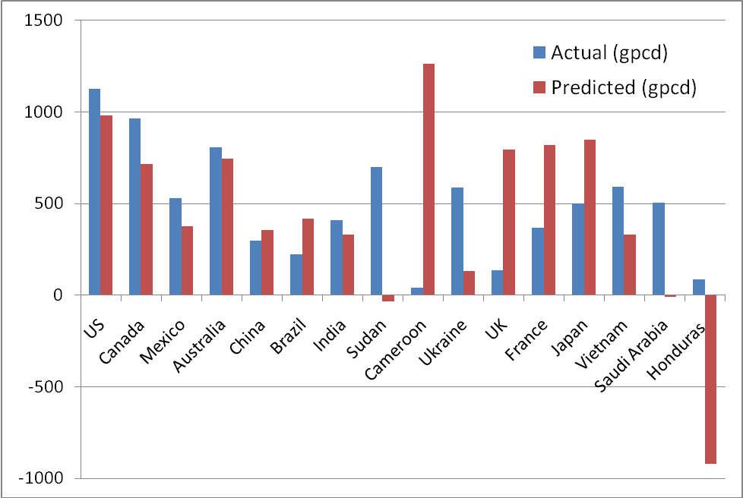

Lastly, we note that the significance of the positive coefficient for the GDP value implies that as residents make more money, they use more freshwater. If we think about it, this makes sense (also note where the freshwater use for the U.S. is compared to other countries on the above plot).

