CE 397 Statistics in Water Resources
Exercise 3

Testing Homogeneity of Suspended Sediment Data

By:
Virginia Smith, Brigit Afshar, Bryan Barnett, Brett Buff, and David Maidment
Environmental and Water Resource Engineering
University of Texas at Austin
February 2009

Contents
Introduction: 2
Goals of this Exercise 2
Computer Requirements 2
Data 2
Procedure: 3
Descriptive Statistics 4
Histograms 5
Equality of the Variance 6
T-Test for Difference in Means 8
To be turned in: 10
Appendix 11

Introduction:
This exercise will be an investigation into methods for testing the homogeneity of databases. The tests that will we be using are t-test. Specifically, we will be applying the paired t-test and the grouped t-test. Sediment data will be used to experiment with these types of tests.

Goals of this Exercise
Sediment data is useful for several types of hydrologic investigations. However, often records of sediment data are short or interrupted. Additionally, sediment data collection methods vary greatly. In this exercise we will look at the sediment record of one area using three sediment datasets. We will use the paired t-tests and grouped t-tests to test the homogeneity of sediment data. This will be accomplished using statistical functions in Excel. The datasets for this exercise were produced by the Texas Water Development Board (TWDB) and the USGS Suspended-Sediment database.

Computer Requirements
This exercise will be done using Excel. The exercise was designed using the 2007 version of Excel. To accomplish the exercise the Data Analysis Toolpak must be used. To use this tool it must first be activated. The directions for this can be found in the attached appendix.
The original data for this project can be downloaded in this spreadsheet: SedimentData.xls The monthly discharge and loading data for this exercise are at: Ex3Data.xls

Data
The data to be used in this exercise was provided by TWDB and USGS. The TWDB data was taken from monthly summaries presented in several “Suspended-Sediment Load of Texas Streams” reports (e.g. See report 184 at http://www.twdb.state.tx.us/publications/reports/GroundWaterReports/GWReports/GWreports.asp ). The reports feature data from sediment collections over a period of months or years for specific locations in Texas. The sediment data in these reports were collected using the “Texas Method” of sediment collection. The “Texas Method” of collection requires an 8-ounce narrow-neck bottle positioned approximately one foot below the water surface near midstream. The percentage of suspended sediment by weight obtained from the sample is multiplied by the factor 1.102 to obtain the mean percentage of suspended sediment in the vertical profile. All of the TWDB stations are located at or near a USGS stream gage. The gage to be used in this exercise is number 07299200, at Prairie Dog Town Fork on the Red River near Lakeview, Texas. The TWDB data are for the period October 1964 through September 1975.
The USGS also provides sediment data for gage 07299200. However, the data provided by the USGS covers a different period of record, October 1949 through July 1951, and use a different method of sampling. The USGS data was collected using “Depth-Integrated Suspended-Sediment Sampling.” This method entails lowering and raising the sampler into the stream at a constant rate to continuously accumulate a representative sample from a stream vertically. The sampler itself is typically a simple tube shaped bottle with a nozzle on the end. Over the years the design of the sampler has changed slightly.
In addition to gage 07299200, the USGS also collected data approximately 20.500 km upstream at gage 07298500, Prairie Dog Town Fork on the Red River near Brice, Texas, for the period February 1979 through September 1980.. The data from gage 07298500 was also collected using the “Depth-Integrated Suspended-Sediment Sampling.” Figure 1 shows a map of the two locations. Figure 1 shows the location of the gages in relation to each other. For the purpose of this exercise we will call the 07299200 gage location Site 1 and the 07298500 gage location Site 2.
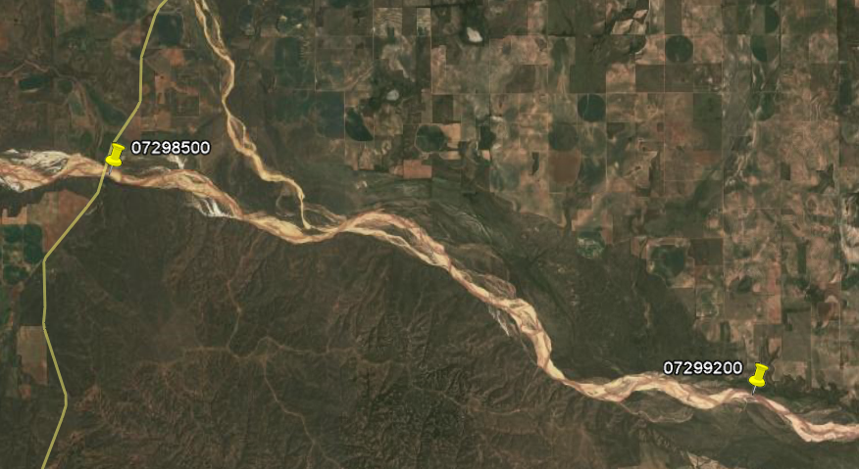
USGS Data
USGS, TWDB Data
Figure 1: Location of the gages near Brice and Lakeview Texas on the Red River.

Procedure:

You have been given the sediment loading data of a sampling location in a stream near Lakeview, Texas at the locations pointed out in the map. Two different methods, USGS Integrated Method and Texas Method, were used to determine the sediment loading values (tons/day).

 | USGS1 | USGS2 | TWDB
Method | USGS Integrated Method | USGS Integrated Method | Texas Method
Site | Site 2 (near Brice, TX) | Site 1 (near Lakeview, TX) | Site 1 (near Lakeview, TX)

The USGS values are from around the same sections of the stream (Site 1 and Site 2) and the USGS2 and TWDB values were both collected from Site 1 but with different methods. We need to determine if these data are homogeneous. In other words, can we consider all of the data sets to be similar enough despite that they sampled using different locations, and despite the difference in location?

Descriptive Statistics
First, use the data to run Descriptive Statistics on the data using the Data Analysis ToolPak for Excel under the Data tab (see Appendix if the Data Analysis button is not available). Run the Descriptive Statistics analysis for each of the data sets individually: USGS1, USGS2, and TWDB.

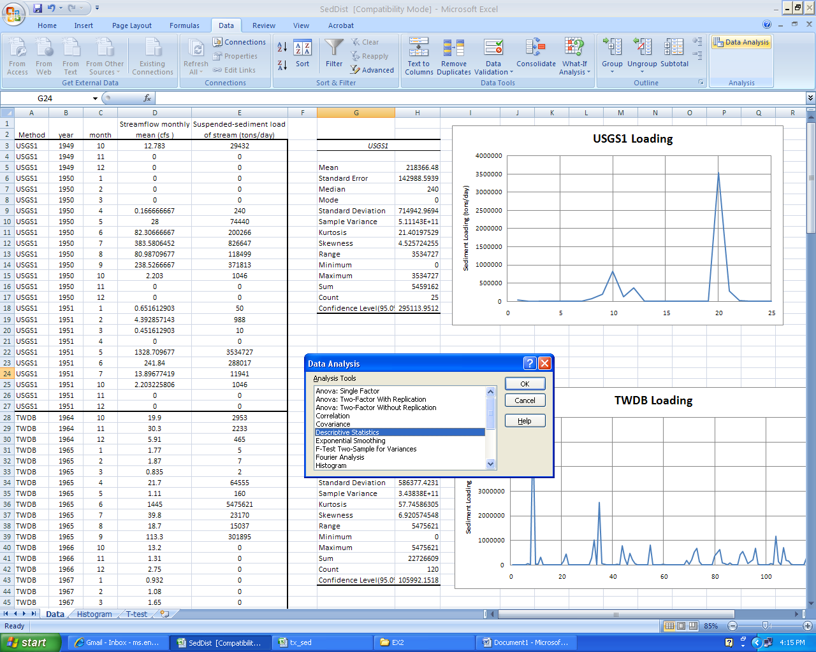
To turn in: Create plots of the sediment loading from each data set. In addition, compare and contrast the descriptive statistics for each datasets. Based on the descriptive statistics alone, do you think that the datasets can be considered homogenous with one another?

Histograms

Next, create histograms using the histogram function on the data analysis toolpak for each of the data sets using the same methods described in exercise 2. Be sure to include cumulative percentages in your plots.

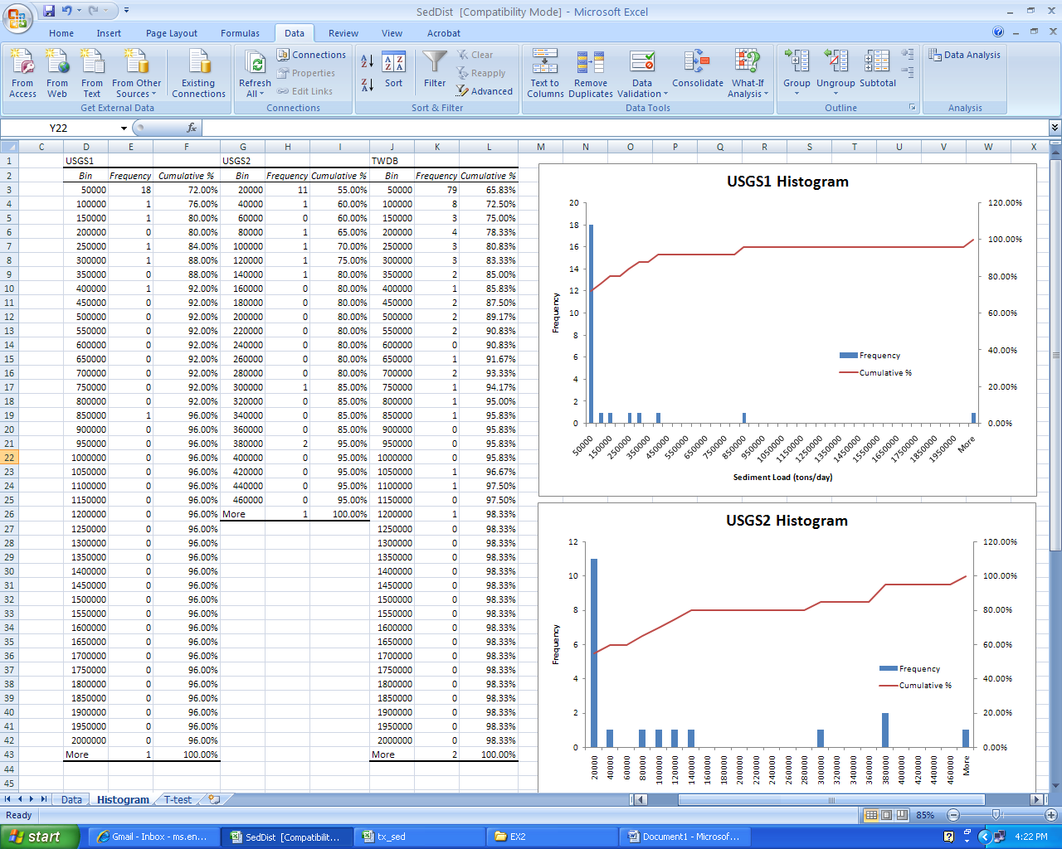

To turn in: Show the histograms of the data sets and discuss similarities and differences in the distribution of sediment loading.

Equality of the Variance
First, we need to determine which grouped t-test to use: equal variance or unequal variance. We can determine the variance by using an f-test. Perform an f-test through the Data Analysis button on USGS1 and TWDB.
Choose F-Test Two-Sample for Variances
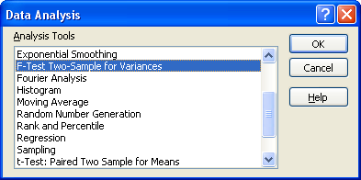
And fill in the data ranges
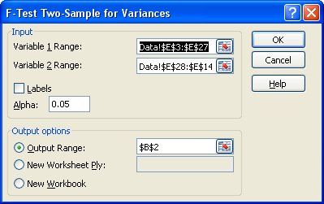
Which produces this result: F-Test Two-Sample for Variances
 | USGS1 | TWDB
Mean | 218366.48 | 189388.4083 | Mean
Variance | 5.11143E+11 | 3.43838E+11 | Variance
Observations | 25 | 120 | Observations
df | 24 | 119 | df
F | 1.486580112 |  | F
P(F<=f) one-tail | 0.085067046 |  | P(F<=f) one-tail
F Critical one-tail | 1.609204301 |  | F Critical one-tail

The F statistic measures the ratio of the two variances against a theoretical distribution (the F-distribution named after R.A. Fisher) that is the ratio of a comparable pair of Chi-square distributions. In this case, the computed F-value of 1.48 has a p-value of 0.08. This means that there is only 8% chance that the difference between the variances is due to randomness alone. Lets assume the variances are unequal. It is shown below that their coefficients of variation are actually almost the same.
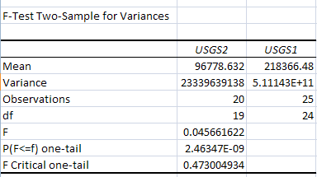

T-Test for Difference in Means
Next, perform a t-test assuming unequal variances using the analysis toolpak the both datasets from Site 1. In this exercise we will be using the t-test to compare two different sampling methods for sediment sampling, depth integrated sampling (used by the USGS) and the Texas method (used by the TWDB). The t-test will determine if the data can be said to be statistically not different from one another.

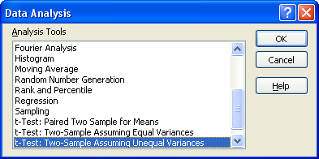

Using the Data Analysis button on the Data tab of Excel, go to the t-Test: Two Sample Assuming Unequal Variances

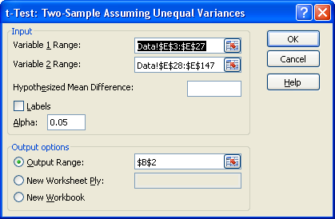
Select all the data available in the USGS (Variable1) and TWDB(Variable2) datasets, and do the test. Put the output Range in a new worksheet.

The following result appears (the standard deviation and coefficient of variation values were added manually to the table below). What this means is that the USGS data have a mean of 218,000 tons/day and a standard deviation of 715,000 tons/day, while the TWDB data have a mean of 189,000 tons/day and a standard deviation of 586,000 tons/day. The difference in the means of the two datasets is 29,000 tons/day. This is a small number relative to the standard deviations of the two datasets. The value of the computed t-statistic is 0.189. Generally if the absolute value of the t-statistic is less than 2 then the null hypothesis cannot be rejected. That is what we conclude in this case. The p-value for the two-sided test is 0.85 and for the one-sided test is 0.425. These are both well above 0.05, so we cannot reject the null hypothesis that the two datasets come from the same population.

t-Test: Two-Sample Assuming Unequal Variances
 | USGS1 | TWDB
Mean | 218366.48 | 189388.4083 | Mean
Variance | 5.11143E+11 | 3.43838E+11 | Variance
Standard Deviation | 714942.97 | 586377.42 | Standard Deviation
Coefficient of Variation | 3.27 | 3.10
Observations | 25 | 120 | Observations
Hypothesized Mean Difference | 0 |  | Hypothesized Mean Difference
df | 31 |  | df
t Stat | 0.190 |  | t Stat
P(T<=t) one-tail | 0.425 |  | P(T<=t) one-tail
t Critical one-tail | 1.696 |  | t Critical one-tail
P(T<=t) two-tail | 0.851 |  | P(T<=t) two-tail
t Critical two-tail | 2.040 |  | t Critical two-tail

To be turned in: Repeat this test assuming equal variances. Do you arrive at a different conclusion? Repeat this exercise comparing the USGS1 and USGS2 datasets, and comparing the USGS2 and the TWDB datasets. Turn in the output for the three t-tests. What do the results of the test tell you? Which datasets are more similar to one another? Based on these tests, are the different methods, sampling periods, and measurement locations, used for the USGS and TWDB datasets significant enough to prevent us from combining datasets, or could the pooled dataset be used to characterize the sediment transport rate at this location on the Red River?

To be turned in:
- Create plots of the sediment loading from each data set. In addition, compare and contrast the descriptive statistics for each datasets. Based on the descriptive statistics alone, do you think that any of the datasets can be considered homogenous with one another?
- Show the histograms of the data sets and discuss similarities and differences in the distribution of sediment loading.
- Repeat this test assuming equal variances. Do you arrive at a different conclusion? Repeat this exercise comparing the USGS1 and USGS2 datasets, and comparing the USGS2 and the TWDB datasets. Turn in the output for the three t-tests. What do the results of the test tell you? Which datasets are more similar to one another? Based on these tests, are the different methods, sampling periods, and measurement locations, used for the USGS and TWDB datasets significant enough to prevent us from combining datasets, or could the pooled dataset be used to characterize the sediment transport rate at this location on the Red River?

Appendix
Excel has a number of statistical procedures built into it. We will use some of these now. First of all, let’s calculate some basic statistics of the mean daily flow values. Under the Data tab, you should find the Data Analysis tool. If the tool is not there, you have to activate it.
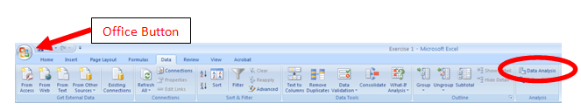
To activate the Data Analysis tool you choose the Office Button and then Excel Options and the bottom of the page that appears.
In the Excel Options window go to Add-ins tab (select on left); at the bottom of the box select the Analysis Toolpak, and then hit the Go… button next to the Manage Excel Add-ins dropdown box at the bottom of the page (its not enough just to double click on the Analysis Toolpak entry in the table).
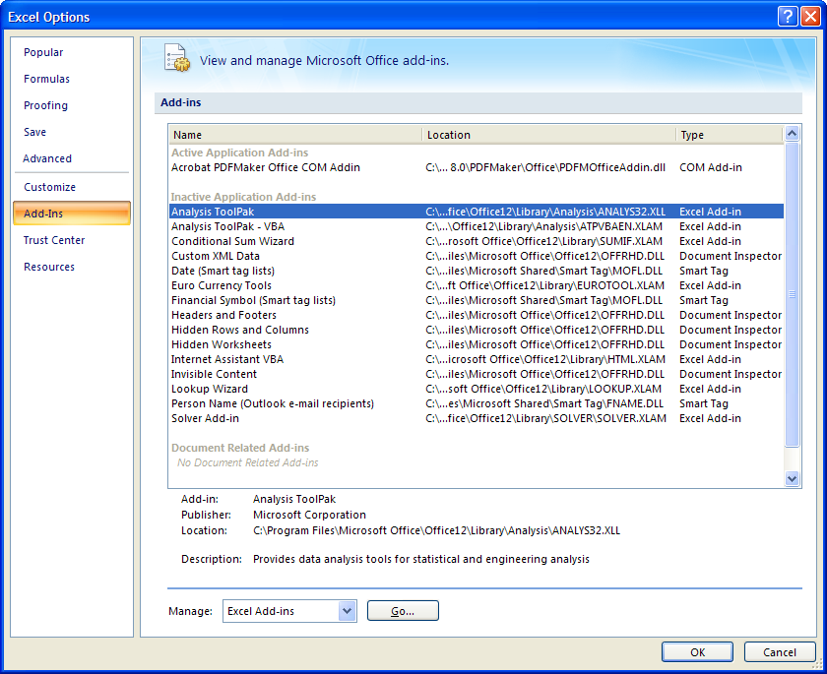.
In the Add-ins pop up box, activate the Analysis Toolpak by clicking in its check box.
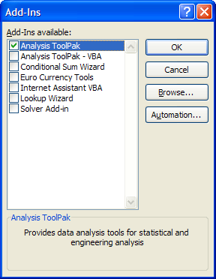
In the Data tab in Excel, you should now see an Analysis box appear to the right of the Outline box.
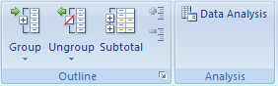
Now we can use the Data Analysis tools. First let’s use the tools to calculate the summary statistics for our 10-years of mean daily flow data. Under the Data tab, select the Data Analysis tool, and select the statistics option you would like to use.

