CE 397 Statistics in Water Resources
Exercise 2: Frequency and Probability Distributions
Key

- Take the last 10 years of the Colorado River flows, 1999 to 2008 and compute by hand or with a hand-developed spreadsheet using the summation formulas (not the internal Excel functions) the mean, standard deviation, variance, median, coefficient of skewness and standard error of estimate of these data. Verify that your results are consistent with those produced by the Descriptive Statistics tool in Excel.
Below is shown my “hand” analysis of the flow data vs. the analysis output from the Excel Descriptive Statistics tool. Happily we see that the computed statistics match.
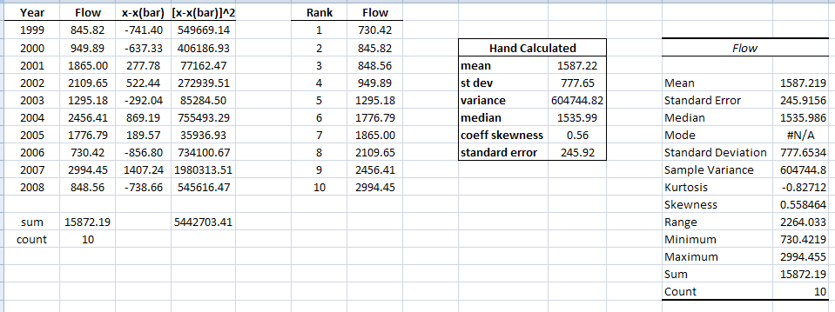
Hand Calculations based on:
Mean:
Standard deviation: 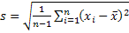
Median:
Coefficient of skewness: 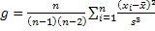
Standard error:

- Use HydroExcel or other means to find another data series of interest to you and set up the Distribution Spreadsheet for these data. Do they fit the normal or lognormal distributions? Write a little story about your data – where do they come from? What did you expect to see before you analyzed them? What did you find out once your analysis was complete?
There are many correct answers to this question. The following is just an example.
For this question, I chose to evaluate the mean monthly flow data from 1959-2009 at USGS Station 05211000, Mississippi River at Grand Rapids MN. I wanted to analyze a natural streamflow in an ephemeral stream in a northern climate. The upper portion of the Mississippi River seemed a good example. Grand Rapids is located in north central Minnesota about 20 miles south of the headwaters of the Mississippi River (see map below). These data were collected using HydroExcel.
I expect the flow patterns here to be different than we see in Texas. The flow should be variable, but not flashy; it should also have a substantial baseflow. Given the level of baseflow, I expect that the data will not be lognormally distributed; they may, however, be close to a normal distribution.


For the first step, I analyzed my data for lognormal and normal distributions using the spreadsheet provided in class. Below are screenshots of the results.
Data
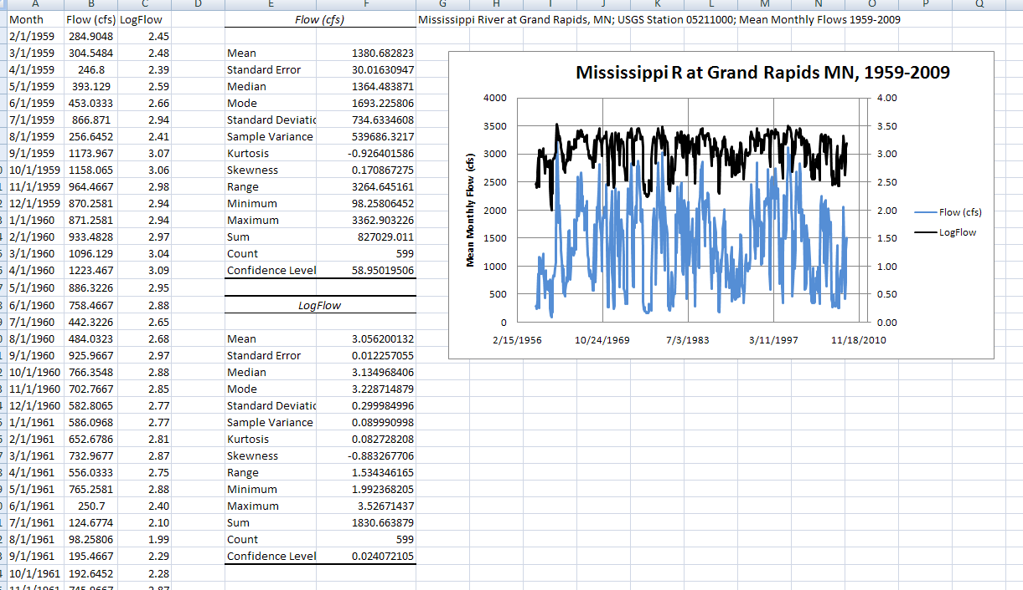

Lognormal Histogram
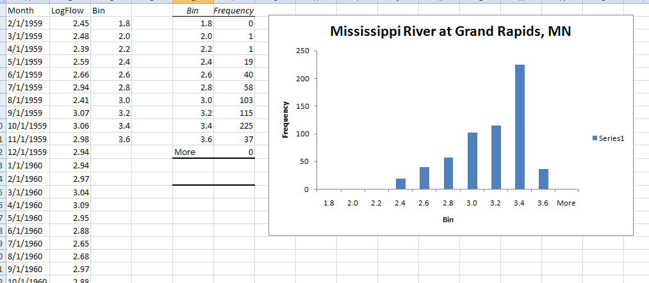
Normal Histogram
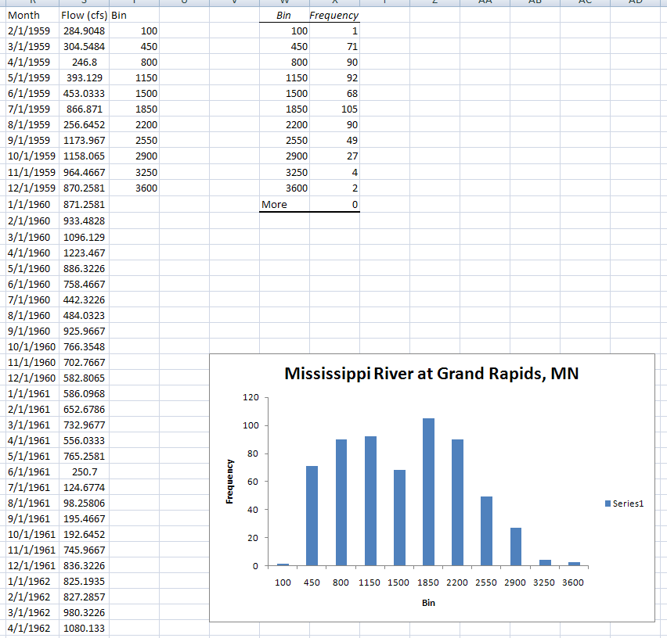
Lognormal Chi Squared Test
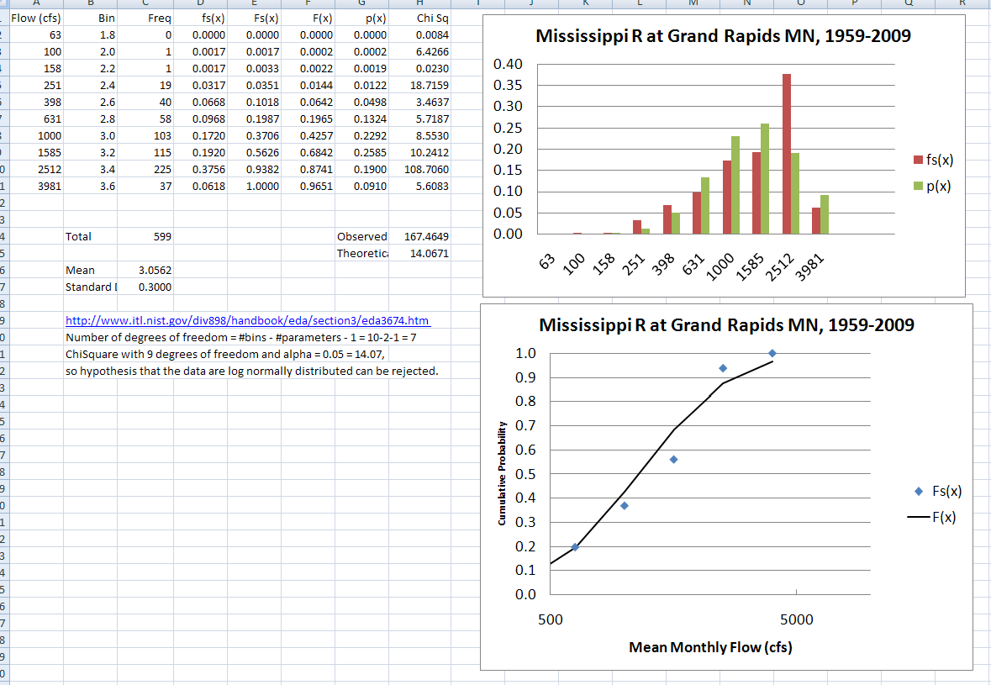

Normal Chi Squared Test
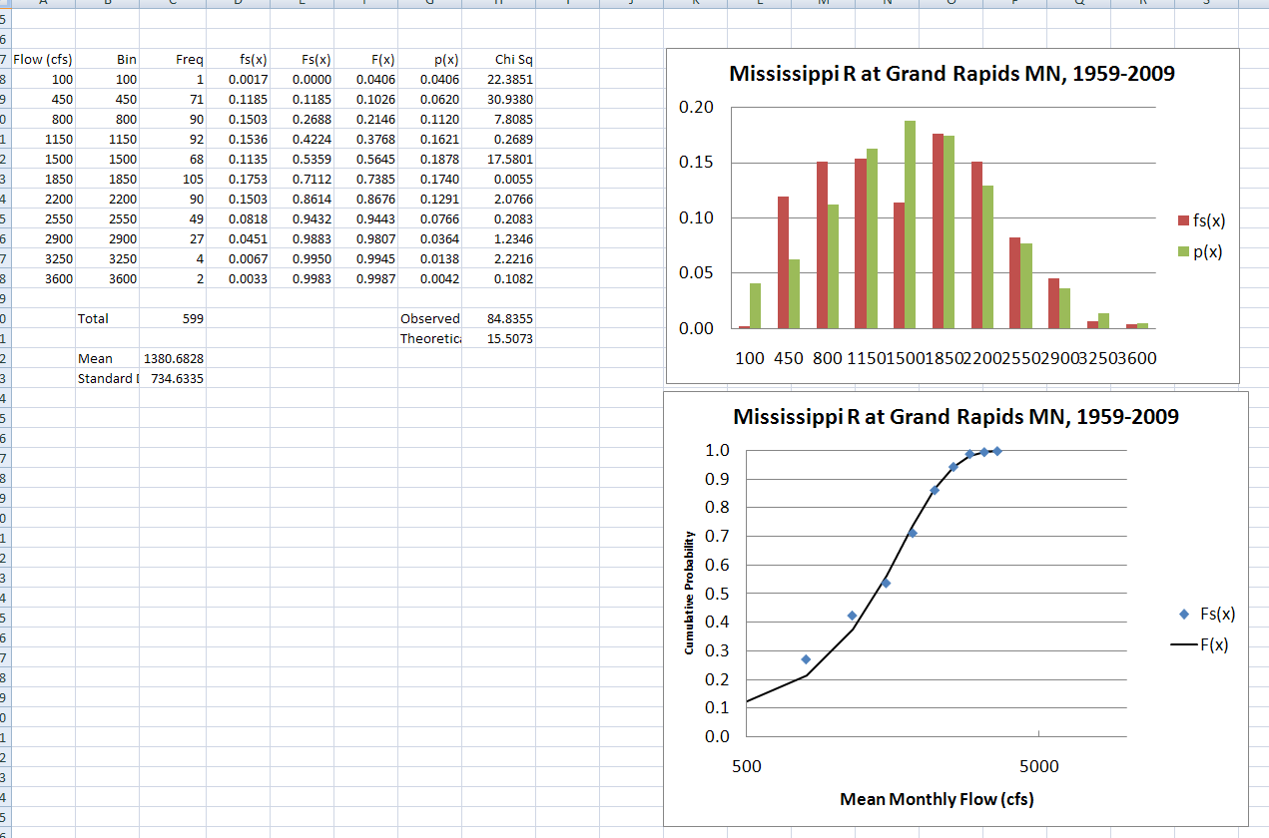
Lognormal Probability Plot
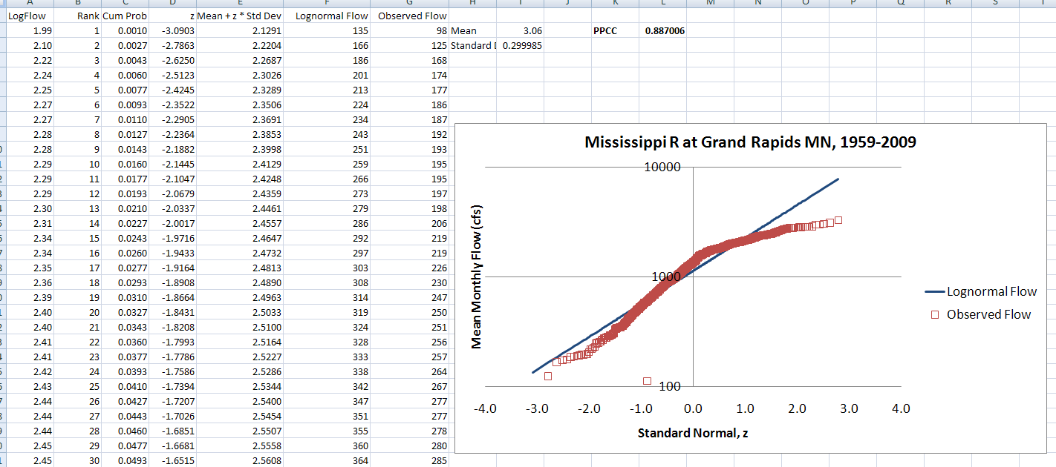

Normal Probability Plot
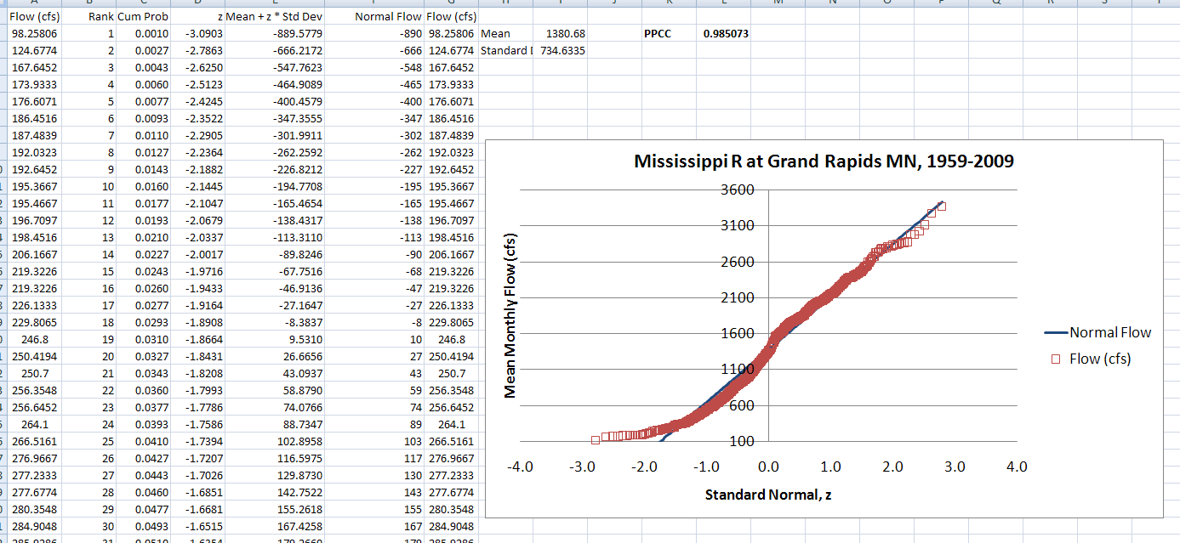
According to this analysis, the 50-years of mean monthly flow data at the Mississippi River at Grand Rapids MN gauge are probably not lognormally distributed. Using the chi squared test to check the normality of the log-transformed data results in an observed chi squared value of 167.47 and a theoretical value of 14.07. I, therefore, reject the null hypothesis of this test; with a 95% confidence level, I am not able to prove that these data are lognormally distributed. Similar results are found when a probability plot of the data is made. The probability plot correlation coefficient is 0.887, which is less than the required 0.95 for a 95% confidence level.
I have mixed results for the test for normality, however. The chi squared test results in an observed value of 84.84 and a theoretical value of 15.5. In this case, I reject the null hypothesis and say that the data are not normally distributed. Using the probability plot, however, I get a probability plot correlation coefficient of 0.9851. This value is larger than the required 0.95 (for a 95th percentile confidence level) and shows that the data agree with the normal distribution.
The pattern that I see in this data is somewhat as I expected. I was surprised that it was so consistent, however. The histogram for the non-transformed flows shows a fairly constant number of data points in the bins from 800 to 2200 cfs with a slight decrease at the 1500 cfs bin. This decrease plays a large role in the non-fit of the chi squared test for normal distribution. Perhaps the flows would be better described by a bimodal distribution. Otherwise I saw statistics that were close to what I anticipated, a non-flashy river with a substantial portion of baseflow.

- Calculate the mean, standard deviation and variance of a random variable X, whose distribution is uniform from 0 to 1.
For the uniformly distributed random variable, X, we know that the probability density function from 0 to 1 must be equal to unity. In other words, . We use this information to calculate the mean as
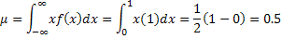
The variance is then
And finally, the standard deviation is simply

- Use the Analysis Toolpak function Random Number Generation to generate 1000 random numbers that are uniformly distributed from 0 to 1. Use a seed of 1. Calculate the cumulative mean of these data. Take the last 50 summed values (ie from 950 to 1000) and fit a normal distribution to them. If you sum uniformly distributed random variables, does the sum become normally distributed? Can you take the formulas you computed in (3) and predict the mean, standard deviation and variance you observe in these last 50 data values?
Below is shown the random numbers generated by Excel and the cumulative mean of these numbers. From the plot, we can see that the cumulative mean stabilizes at around 250 values into the analysis.

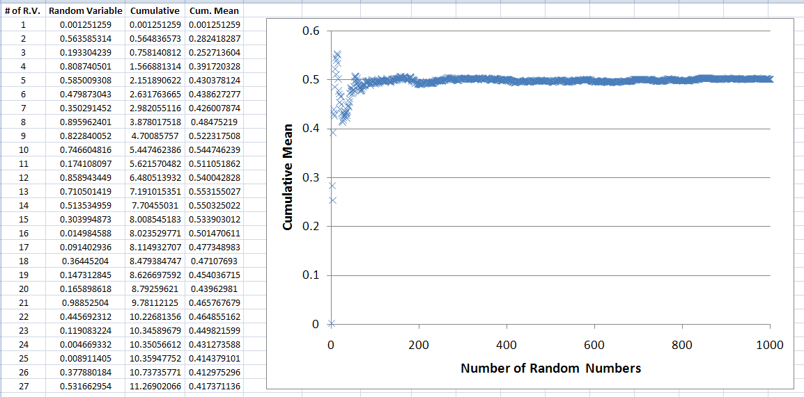

It turns out that having a single generated series of values is insufficient to properly characterize the variability of the cumulative mean of these series. The theoretical variance is 1000² *(0.0833/1000 = 0.00008333. In some cases, the variance computed from the last 50 values of a single series was about one half of this value. After some experimentation, a set of 100 replicates of the 1000 random variables was generated and the cumulative mean of each of the 100 series was computed. Then, a variance of these means was computed beginning just with two series, three series, four series, …., 100 series. The result is presented below, which shows that about 10 replicates are needed to get the variance in the right region, and that after 100 replicates the variance is at the theoretical value, although there is a considerable fluctuation around that value before it is reached.
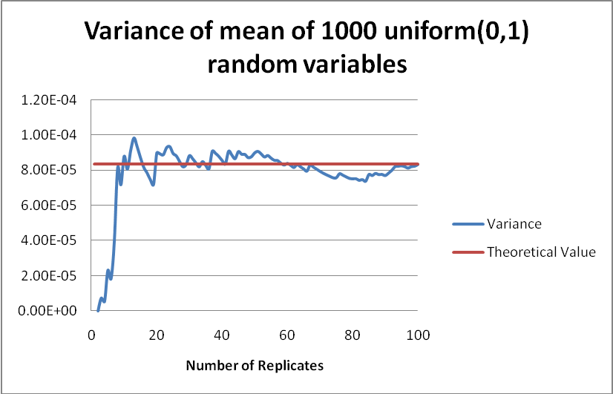
A similar exercise performed on the average of the cumulative mean of two replicates, three replicates, …, 100 replicates, is shown below
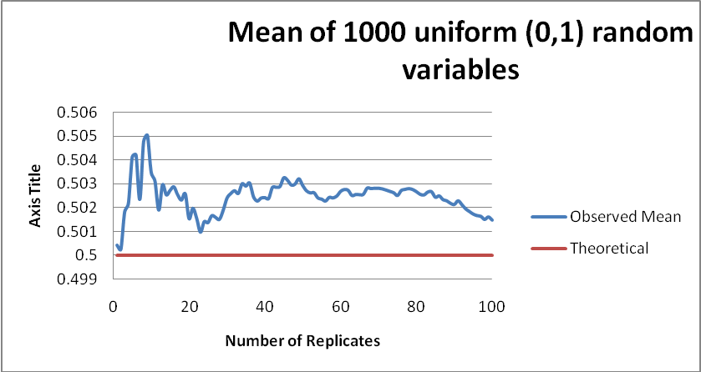
This shows that the observed mean is slightly biased above its theoretical value of 0.5.
Lastly let’s check out the normality of the 1000’th random variables in these lists (the last random variable in these 100 replicate lists). We can take these 100 values and put them through our tests of normality: the chi squared test, a cumulative distribution plot, and a probability plot. Here’s what we get.
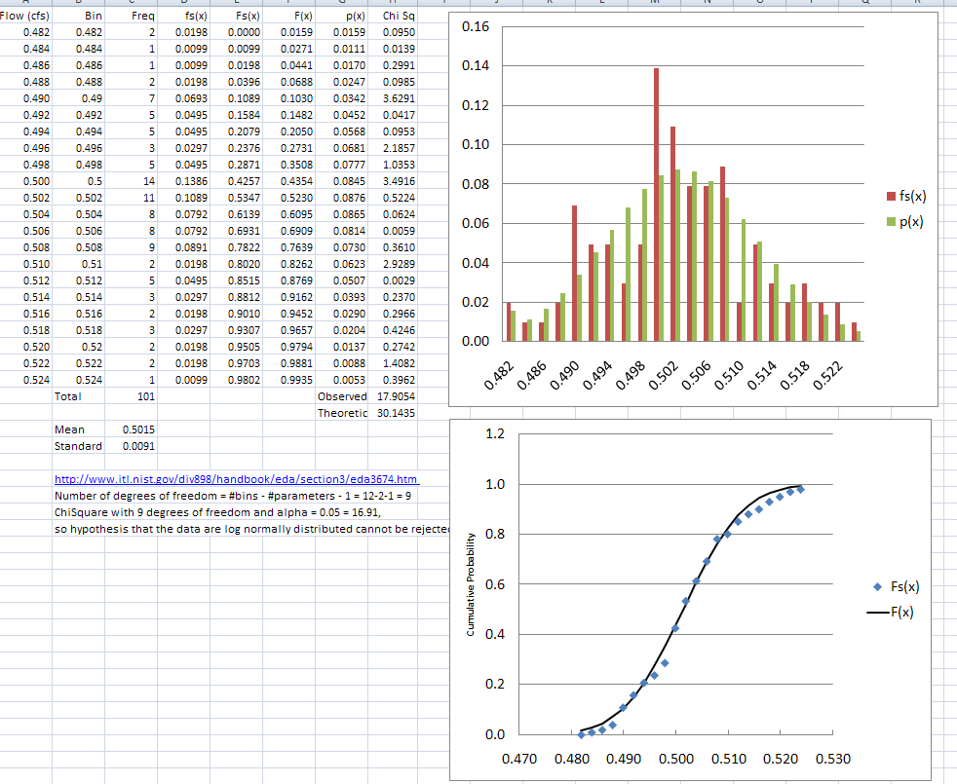

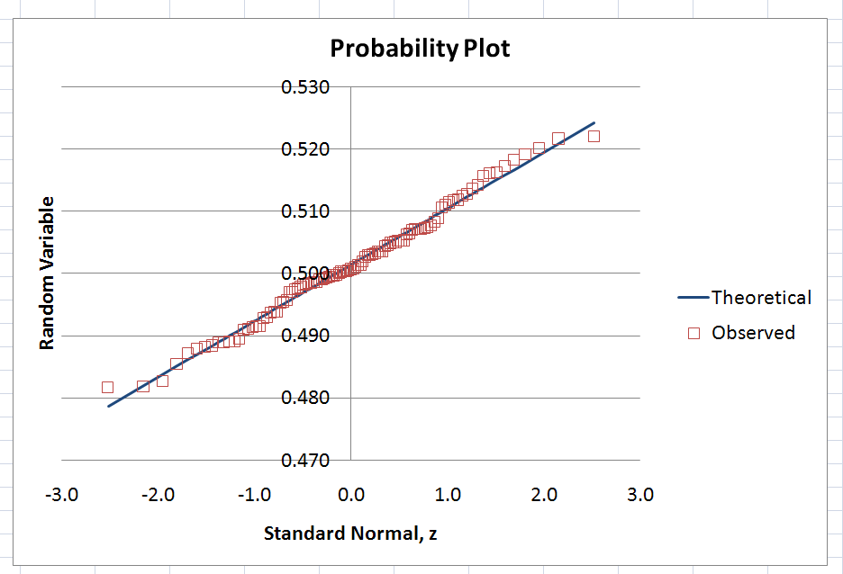
All tests show a result that our data is, indeed, normally distributed. We said above that we’d expect the random variables to be normally distributed with a mean of 0.5 and a standard deviation of 0.0091 (based on our theoretical calculations). Assessing the 1000’th values of 100 trials gives us the result that we hoped for.
These exercises demonstrate the sample properties of theoretical distributions have to be carefully constructed and they don’t converge to the true values without significant replication.

Now let’s use our results from Question 3 to predict the mean, standard deviation and variance of 1000 independent and identically distributed random variables. If we sum 1000 random variables that are uniformly distributed from 0 to 1 we expect that
We also know that the variance of the sum of independent and identically distributed random variables is the sum of the variances of those numbers.
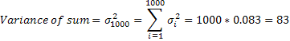
Our standard deviation is then
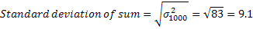
We therefore have a normally distributed variable with a mean of 500 and a standard deviation of 9.1.
The expected distribution of these variables is then
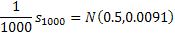
With a mean value of 0.5 and a variance around that mean of (0.0091)²=0.000083.

