CE 394K.2 Hydrology

Homework 4

Evaporation at Shale Hills

A Critical Zone Observatory has been established in the Shale Hills watershed which is located near Penn State University in State College, PA. The Critical Zone is from the top of the bed rock to the tops of the trees. It is part of the Susquehanna River Basin Hydrologic Observatory System http://www.srbhos.org/ Observational data are measured there and are provided through CUAHSI web services at the WSDL address: http://cbe.cae.drexel.edu/wateroneflow/SRBHOS.asmx?WSDL

You can download these data into Excel using a web services spreadsheet obtainable at: ODMwsSRBHOS.xls To operate this spreadsheet, you need the CUAHSI HydroObjects package installed first on your computer. You can get this at: ftp://ftp.crwr.utexas.edu/pub/outgoing/CUAHSI/HydroObjects/HydroObjectsSetup.zip

A tutorial on how to use this spreadsheet can be seen at: http://www.watersnet.org/wtbs/tutorials/ODMws.html You must Enable Macros in Excel to make this spreadsheet work.

The following data are available at the RTHNet measurement site:

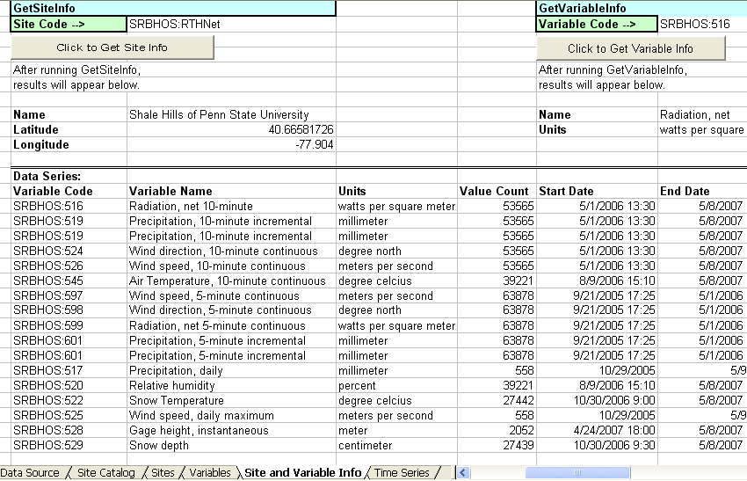

Please use these data and the web services spreadsheet to answer the following questions.

(1) Plot the diurnal variation in net radiation (Variable SRBHOS: 516) over an average day in July 2006 and January 2007. What is monthly average value of net radiation for each of these two months (W/m²).

(2) Calculate the monthly average net radiation for May 2006 to April 2007 and make a plot of that to show the seasonal variation in this phenomenon. What is the average value of net radiation for this 12-month period (W/m²)?

(3) Take the meteorological data for air temperature (SRBHOS:545), wind speed (SRBHOS: 526), relative humidity (SRBHOS: 520), and net radiation and calculate the daily average evaporation (mm/day) for each day in September 2006, and March 2007.

(4) Plot the daily evaporation and precipitation for these two months.

(5) For September 10, 2006 and March 10, 2007, plot the diurnal variation in air temperature, wind speed, relative humidity and net radiation. Calculate and plot the corresponding diurnal variation in evaporation.

This assignment is due in on Thurs Feb 21.

