Lab 4b

Name____________________________________Date____________Time___________

Problem 5.78—Engineering Fluid Mechanics (Crowe, Elger and Robertson)

A suction device is being designed based on the venture principle to lift objects submerged in water. The operating water temperature is 15º C. The suction cup is located 1 m below the water surface, and the venture throat is located 1 m above the water. The atmosphere pressure is 100 kPa. The ratio of the throat area to the exit area is ¼, and the exit area is 0.001 m². The area of the suction cup is 0.1 m².
- Find the velocity of the water at the exit for the maximum lift condition.
- Find the discharge through the system for maximum lift condition.
- Find the maximum load the suction can support
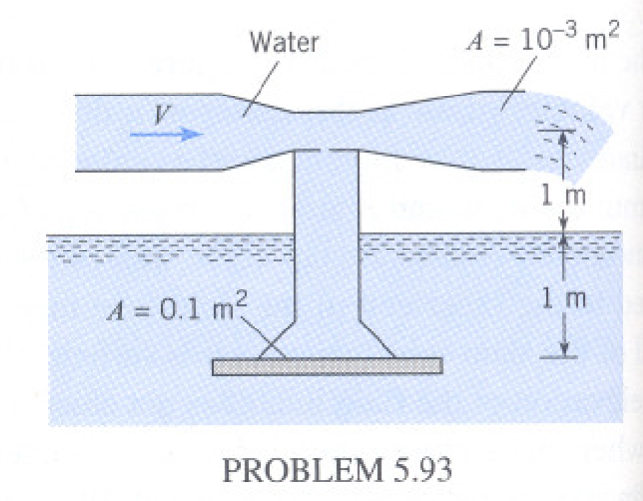

P_{v} _{15C}= 1700 Pa ρ=999 kg/m³ Patm=100 KPa T_{water}=15º C
A_{e}=10⁻³ m² Δh= 2 m A_{s}= 0.1 m²

a) Write the Bernoulli equation from the throat to the exit of the channel. The pressure at the throat is equal to the P_{v}.

Also V_{t}A_{t}=V_{e}A_{e}
V_{t}=V_{e}A_{e}/A_{t}=___V_{e}

Substitute the value into the Bernoulli equation written above and solve for V_{e}.

V_{e}=________m/s

b) Q= V_{e}*A_{e}=________*________=________m³/s

c)
P_{suction}= P_{t} + γΔh
P_{suction} =_____________+__________*__________=_____________Pa
The pressure surrounding the suction (ΔP) will be the difference between P_{water} and
P_{suction}.
P_{water}= Patm + γ * 1 m= _________Pa
ΔP= P_{water} - P_{suction}= ________ Pa -_____________Pa = ___________Pa

Max Lift
F_{lift}= ΔP * A_{s} =_________N/m² *_________m²= ____________N

